Project Design Phase-II
Data Flow Diagram & User Stories

Date | October 3, 2026
Team ID
Project Name | Automated Network Request Management System
Maximum Marks | 4 Marks

Data Flow Diagrams:
A Data Flow Diagram (DFD) is a traditional visual representation of the information flows within a system. A neat and clear DFD can depict the right amount of the system requirement graphically. It shows how data enters and leaves the system, what changes the information, and where data is stored.
Section A: Data Flow Description (DFD Architecture)
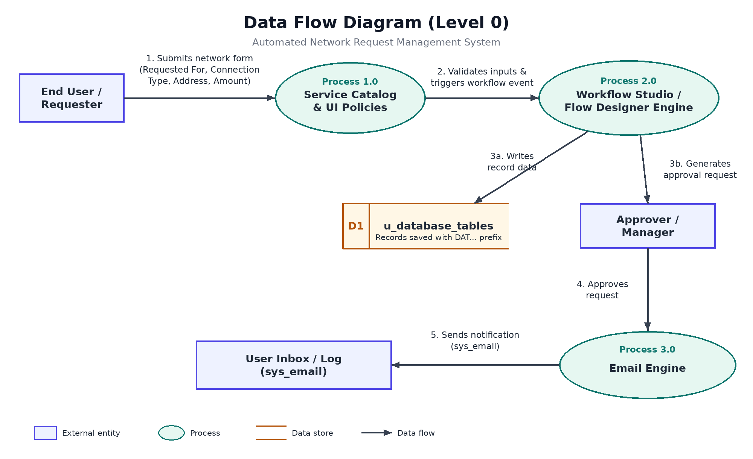
Text Narrative for DFD Steps:
User Request Entry: The End User opens the Service Catalog and fills out the Network Request form.
Form Validation: Catalog UI Policies enforce required fields and toggle visibility before passing parameters to Workflow Studio.
Record Generation & Approval Routing: Flow Designer extracts catalog variables, generates a record in custom table u_database_tables (DAT... prefix), and routes an approval task to the Approver.
Approval Execution & Notification: Upon approval, Flow Designer updates the record state and triggers the Email Engine (sys_email) to deliver an automated notification.
Section B: User Stories

Use the below template to list all the user stories for the product.
User Type | Functional Requirement (Epic) | User Story Number | User Story / Task | Acceptance criteria | Priority | Release
End User (Employee) | Service Catalog Request | USN-1 | As a user, I want to fill out a Network Request form on the Service Catalog so that I can request network setup or modifications. | Form is accessible from portal with all required fields visible (Requested For, Connection Type, Amount). | High | Sprint-1
End User (Employee) | Form Validation | USN-2 | As a user, I want dynamic field visibility so that I only fill in relevant connection parameters. | UI Policy visible/hide of ID field dynamically toggles fields based on my selection. | High | Sprint-1
IT Approver / Manager | Approval Processing | USN-3 | As a manager, I want to review pending requests so that I can approve or reject provisioning. | Approval state transitions correctly from Requested to Approved in ServiceNow. | High | Sprint-1
System Administrator | Data Management | USN-4 | As an admin, I want submitted requests saved in u_database_tables so that records are indexed with auto-numbering. | Records are generated automatically with DAT auto-numbering and variables populated. | High | Sprint-1
End User (Employee) | Email Notification | USN-5 | As a user, I want to receive an email notification when my request is approved so that I know fulfillment has started.

